**Use of Fonts & Icons**

**CSS Fonts :**

<html>

<head>

<style>

.p1 {

  font-family: "Times New Roman", Times, serif;

}

.p2 {

  font-family: Arial, Helvetica, sans-serif;

}

.p3 {

  font-family: "Lucida Console", "Courier New", monospace;

}

</style>

</head>

<body>

<h1>CSS fonts</h1>

<p class="p1">This is a paragraph, shown in the Times New Roman font.</p>

<p class="p2">This is a paragraph, shown in the Arial font.</p>

<p class="p3">This is a paragraph, shown in the Lucida Console font.</p>

</body>

</html>

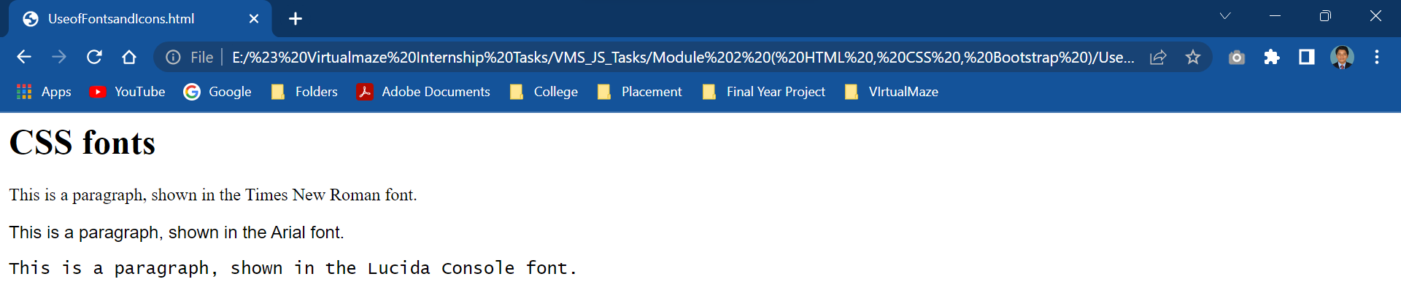

**CSS Icons :**

1.Google Icon Library

2.Bootstrap Icon

 <html>

 <head>

 <title>Google Icons</title>

 <meta name="viewport" content="width=device-width, initial-scale=1">

 <link rel="stylesheet" href="https://fonts.googleapis.com/icon?family=Material+Icons">

 </head>

 <body>

 <h1>Google icon library</h1>

 <p>Some Google icons:</p>

 <i class="material-icons">cloud</i>

 <i class="material-icons">favorite</i>

 <i class="material-icons">attachment</i>

 <i class="material-icons">computer</i>

 <i class="material-icons">traffic</i>

 <br><br>

 <p>Styled Google icons (size and color):</p>

 <i class="material-icons" style="font-size:24px;">cloud</i>

 <i class="material-icons" style="font-size:36px;">cloud</i>

 <i class="material-icons" style="font-size:48px;color:red;">cloud</i>

 <i class="material-icons" style="font-size:60px;color:lightblue;">cloud</i>

 </body>

 </html>

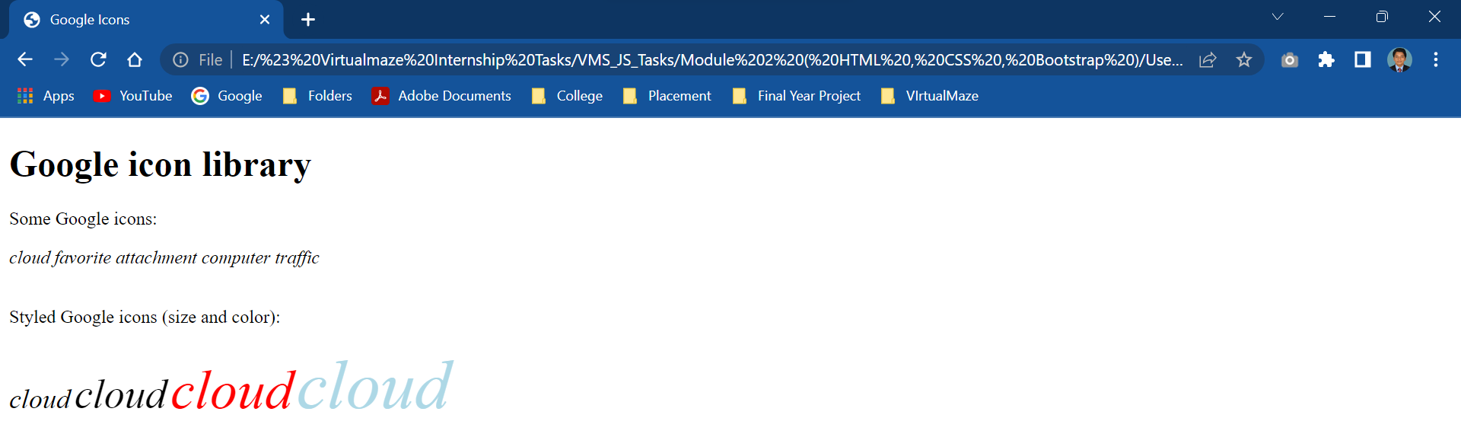

<html>

<head>

<title>Font Awesome Icons</title>

<meta name="viewport" content="width=device-width, initial-scale=1">

<script src="https://kit.fontawesome.com/a076d05399.js" crossorigin="anonymous"></script>

<!--Get your own code at fontawesome.com-->

</head>

<body>

<h1>Font Awesome icon library</h1>

<p>Some Font Awesome icons:</p>

<i class="fas fa-cloud"></i>

<i class="fas fa-heart"></i>

<i class="fas fa-car"></i>

<i class="fas fa-file"></i>

<i class="fas fa-bars"></i>

<p>Styled Font Awesome icons (size and color):</p>

<i class="fas fa-cloud" style="font-size:24px;"></i>

<i class="fas fa-cloud" style="font-size:36px;"></i>

<i class="fas fa-cloud" style="font-size:48px;color:red;"></i>

<i class="fas fa-cloud" style="font-size:60px;color:lightblue;"></i>

</body>

</html>

